# Materials and methods

## Materials used

|  |  |  |  |
| --- | --- | --- | --- |
| Material | Application | Maker | Origin (City, Country) |
| Ethanol | Cleaning and sanitizing surfaces | Gadot | Netanya, Israel |
| HPLC Water | Raman experiments |  |  |
| HPLC Water | Fluorescence experiments |  |  |
| Aluminum foil |  |  |  |
| Agar |  | Difco | Sparks, USA |
| LB Broth |  | Difco | Sparks, USA |
| L-tryptophan | Fluorescence calibration | Sigma-Aldrich | St. Louis, USA |
| Sodium Chlorida (NaCl |  | Biolab | Jerusalem, Israel |

## Bacterial Strains

The following bacterial strains were used in this study: *E. coli* DH5α, *B. subtilis* 3610, *Pseudomonas aeruginosa* PA14 and *Clavibacter amylovora* of unidentified strain*,* all strains were taken from the lab stocks at Volcani Center.

Bacteria were transferred from pure cultures stored at -20 0C (with 20% glycerol solution) and were grown on LB agar medium (Difco, Sparks, MD, USA) and incubated at 37°C overnight. Several well isolated colonies were harvested, suspended in a 10 or 15 ml volume of LB broth (Difco, Sparks, MD, USA) and incubated at 37°C with shaking for overnight to prepare a starter culture. The stocks were later used in the sample preparation procedure in different ways for different experiments.

## Optical density to bacterial concentration calibration

In order to associate optical density with microbial concentration, liquid bacterial cultures were diluted to optical density (OD) of 1 using a benchtop photometer (Biochrom, Cambridge, UK) at 590 nm. The cultures were then serially diluted between 1:10 and 1:1010 and 100µL were plated on agar plates and incubated overnight in 37°C. Each dilution was plated 3 times for replicates, and 3 plates were incubated without inoculation as controls. After incubation, colonies were counted on the plates and the bacterial concentration of a 1 OD liquid culture was calculated to be ~108 CFUs/ml in *E. coli* and *B. subtilis* and *C. amylovora* and ~109 CFUs/ml in *P. aeruginosa*.

## Preparation of L- tryptophan solution

A 107 ppb stock solution was prepared by dissolving 1 g of L-tryptophan powder (CAS number 73-22-3, Sigma-Aldrich, St. Louis, MO, USA) into 100 ml of non-fluorescence water (???) over 100°C using an electric stirrer. Visually, tryptophan was fully dissolved in water which is expected due to its high aqueous solubility at room temperature (11.4 g/L at 25 °C). The tryptophan stock solution was serially diluted and 10 ml of tryptophan solution at concentrations of 0.1, 1, 2, 3, 5 and 10 ppb were made.

## Survival test under sample preparation, transfer and radiation

In order to make sure irradiation by the 785nm laser does not compromise cell viability, a sample of water with 108 CFU/ml and clean water were placed in the aluminum cup and irradiated by laser for 30 seconds (exactly the same way in which we scan normally). After that, the samples were diluted 1:103, 104, 105, 106 and plated on agar plates. The plates were incubated for 24 hours in 37°C and colonies were counted.

## Sample preparation for Raman scanning

Prior to scanning with Raman instrument, 15ml of bacteria culture were grown overnight in optimal conditions. The bacterial culture was centrifuged for 10 minutes at 4991 g. The supernatant was thrown away and the bacterial pellet re-suspended in 15ml of distilled water or saline (depending on the experiment). This washing stage was repeated 3 times, and the final pellet was re-suspended in distilled water or saline to the volume necessary to reach optical density of 1. The sample was later diluted according to each experiment in serial dilutions. The samples were kept at room temperature at all times after this and were measured 1-3 hours after the preparation stage. Different sample preparations were used in part of the experiments and will be described here:

### Pellet

In this experiment the goal was to scan bacteria as a pellet, with a low concentration of water and with as few other substances as possible. To achieve this, bacteria were washed as in the standard sample preparation but the final pellet was not re-suspended but scraped and loaded onto the aluminium cup. In order to get a large enough pellet, 2 starter cultures (15 ml each) were combined before the final centrifugation step.

### Saline

In this experiment the goal was to improve the bacterial Raman signal by suspending the bacteria in saline (0.9% NaCl). The rationale was that bacterial cells might be under osmotic stress in distilled water and are changing their optical properties. In this experiment all distilled water was replaced by autoclaved saline but the sample preparation was otherwise unchanged.

### Glass slides

In experiments done on glass slides the goal was to reduce scatter and reflectance from aluminium cup and (in some experiments) to reduce water content effect on the signal by drying the samples on the slides. After standard sample preparations, microscope glass slides (???) were loaded with 50 µL droplets of the samples. The slides were put into petri dishes and air-dried in an incubator at 37°C overnight.

### Aluminium slides

In this experiment the goal was to reduce the effect of water content on the signal by drying the samples. Roughly 10x3 cm cuttings of thick aluminum foil (???) were made and 50 µL droplets of samples were placed on top of the cuttings. The slides were put into petri dishes and air-dried in an incubator at 37°C overnight.

### “Dirty” experiment

In this experiment the goal was to keep the bacteria’s natural chemical environment in order to get a signal from both the bacteria and their environment. For this purpose, 15ml of overnight cultures were diluted in LB broth to OD of 1 and serial dilutions were made in LB broth to get a range of concentration between 106 – 10 CFU/ml. Samples were kept in ice to inhibit growth during transfer and scanning procedure, but brought to room temperature for actual Raman scanning.

### Milk

In this experiment the goal was to understand if the method will be applicable for use on milk samples. For this, bacterial cultures were washed as previously described and then diluted in Ultra-high-temperature treated (UHT) 3% fat milk (Tnuva, Israel). UHT milk was used because it is supposed to be sterile, and sterility was partially affirmed by inoculating 100µL of milk on agar plates and incubating for 72 hours in 37°C and 30°C.

### Other treatments

Other treatments were used in an attempt to increase bacterial Raman signal, these however were quickly disregarded and no serial dilution data was created. These other treatments included: boiling bacteria for 15 min in 100°C in hot plate (???), cooling bacteria in ice for an hour (this has been shown by Premasiri et al (2017) to increase certain molecular moieties that are Raman active) and lysing cells by suspending them in 90% ethanol.

# Raman Scanning and set-ups

## Instrumentation and scanning procedure

For all Raman experiments, a 785nm excitation laser was used (Ocean Optics laser module I0785MM0350MS, Ocean Optics, Largo, USA), coupled with a spectrometer (Ocean Optics QE65 Pro, Ocean Optics, Largo, USA) with a range of 160.7-4142.2 cm-1 (or 766 – 1100 nm). Readings were done using a stainless steel fiber optic probe (RamanProbe II 785/12-5, InPhotonics, Norwood, USA) attached to both laser and spectrometer. All data was collected using the Oceanview version XXX software (Ocean Optics, Largo, USA) and exported as .CSV files for further analysis (fig. 1).

Unless otherwise stated, scans were done at 350 mW for 10 seconds, with 3 immediate scans averaged (for a total of 30 seconds exposure time). The height of the probe was adjusted to the best resolution of the peaks of 100% ethanol prior to all scans. Dark scans were measured with the laser off and auto-subtracted from all data to remove machine noise.

The scanning procedure was, after taking dark and adjusting probe height, to clean the aluminum cup (fig. 1) with 100% ethanol and delicate task wipers ('kimwipes', Kimberly-Clark, Irving, USA) and load 150µL of sample onto the cup. The aluminum cup was then placed under the probe and brought to correct height with all light sealed out. At this stage the laser would be turned on and the scan started. After each scan the cup would be cleaned and reloaded. Each sample was scanned 3-5 times (depending on the experiment).

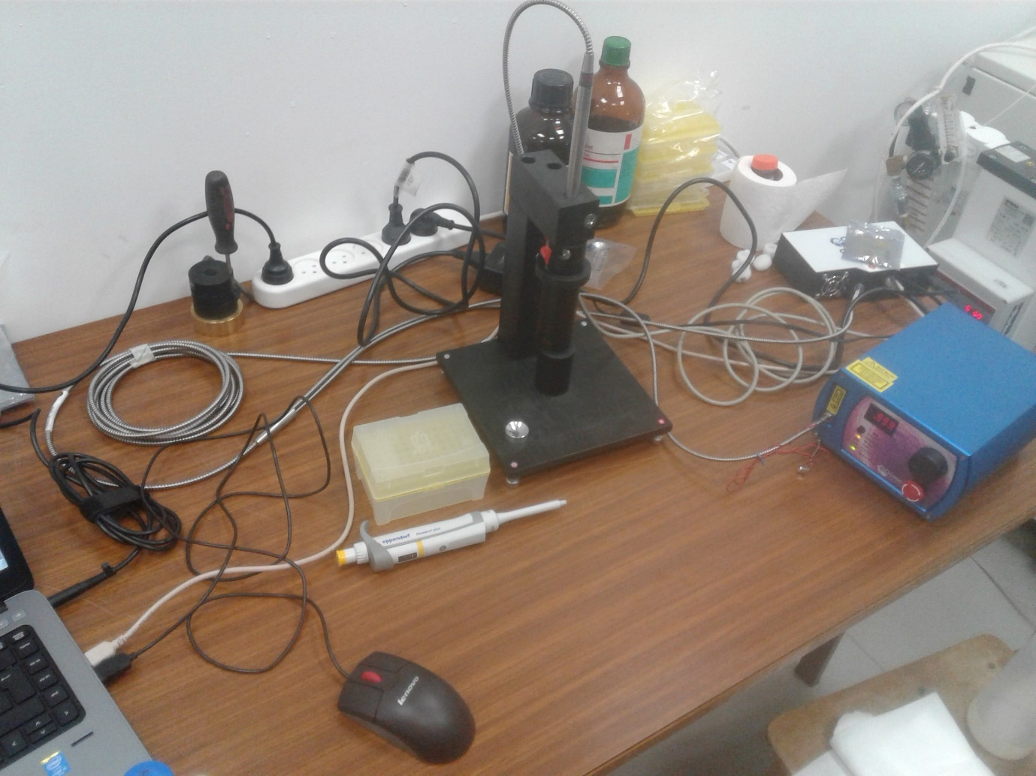

1

3

2

4

5

Figure 1. The Raman setep, including (1) excitation laser, (2) Probe, (3) spectrometer, (4) probe holder and (5) aluminum cup.

# Water sampling

Water samples were taken from 6 drinking water drillings in Israel between July 2017 and June 2018 before and after standard chlorination treatment. The list of the drillings, the number of sampling events and the frequency of sampling are listed in Table X. Water was collected in cleaned dark glass bottles and transported in coolers to the laboratory where it was stored in 4°C until analyzed. Some samplings were cancelled due to unavailability of the drill site reported by the water authorities.

Table X. Water sampling schedule

|  |  |  |
| --- | --- | --- |
| Well (code) | Sampling Frequency | Number of samples prior chlorination |
| Alonei Ha’Bashan 5 (AAI05) | Monthly | 11 |
| Alonei Ha’Bashan 8 (AAI08) | Monthly | 10 |
| Kidmat Tzvi 1 (KDZ) | Intermittently between October 2017 and June 2018  22/10 26/12 15/01 20/03 23/04 23/05 18/06 | 7 |
| Shimron 7 (SH7) | Monthly | 11 |
| Einan 3 (QP003) | Summer (July-December 2017, March-June 2018): 2 per month  Winter (January-February 2018): 2 per week | 26 |
| Einan 6 (QP006) | Summer (July-December 2017, March-June 2018): 2 per month  Winter (January-February 2018): 2 per week | 34 |
| Total samples |  | 99 |

# Water samples standard testing

All drinking water samples were sent simultaneously to be analyzed in a service lab according to standard methods (ref) for: coliforms, fecal coliforms, fecal streptococci, heterotrophic bacterial counts and turbidity. In chlorinated samples chlorine concentrations were also measured. All testing was done by qualified personnel according to ministry of health standards and results were sent online.

# Water sample preparation

250 or 500 ml of water from drillings were sampled by trained personnel according to standard water sampling procedure (ref – min. of health) and transported in coolers to our lab in the Volcani Center (Rishon L’etzion). The water was put in 4°C until scanning. Prior to scanning the water was brought to room temperature by leaving the bottles in room temp for approx. 3 hours. Cuvettes were washed 3 times with HPLC-grade water before the beginning of sampling, and washed by 6 ml of sample water between each scan. 3 ml of sample water were loaded for scanning. The cuvette was wiped with delicate task wipers ('kimwipes', Kimberly-Clark, Irving, USA) before each scan and was aligned to the same side for scanning.

# Fluorescence Scanning

Fluorescence spectra of all water samples were measured with an RF-5301PC spectrofluorometer (Shimadzu, Kyoto, Japan) equipped with 150-W Xenon lamp (Ushio Inc., Tokyo, Japan) as described by Borisover et al. (2009, 2011). The cuvette used was the standard quartz cell (Hellma, Müllheim, Germany) having a path length of 10mm and the chamber volume of 3,500 μL. Excitation–emission matrices (EEMs) were generated at 22±2°C. Fluorescence emission spectra between 220 and 450 nm were collected at 2-nm increments, with excitation wavelengths ranging from 210 to 400 nm at 5-nm increments. Scanning rate per map was about 2.5 minutes and the excitation and emission optical slits were set to 10mm. Instrument stability was controlled by measuring the intensity of the Raman peak of water at excitation wavelength at 275 nm and emission wavelength at 305nm

# UV Scanning

Optical density at 210nm was checked in every drinking water sample before fluorescence measurement using a Genesys UV-Visible spectrophotometer (Thermo Scientific; Cat. 335906-02; Madison WI 53711; USA) to ensure it is sufficiently low to prevent an inner filter effect.

# Mathematical sample preparation – preprocessing

All preparation of data for analysis is called preprocessing. We first calibrated our protocol to find the best preprocessing procedure by comparing all the following techniques:

1. Normalization; this process is supposed to reduce noise since the ratio of signal to a set point that is theoretically stable over different measuring periods, temperatures (within 25±5°C) and varying intensities of lamp light will eliminate all the said interferences.

In the Raman experiments this was done by dividing all intensities in the spectra by the maximum point in the spectra, thus achieving a range of 0-1 for all datapoints, while retaining the relations between different peaks (ref?)

In the fluorescenece experiment, this was done by dividing the signal to the Raman signal of water; different definitions of the Raman signal are elaborated in Table 1.

Normalization was done using Excel software

1. centring and Scaling processes were done automatically using the JMP software prior to running the PLS analysis. These reduce noise to enable better fitting of the model and are commonplace in PLS analysis (Geladi and Kowalski 1986).
2. 1/signal and log10(1/signal); this is another normalization approach, and is generally used to increase weak signals and uncover more information about a sample (Mizrah 2007). these were calculated using Excel software.
3. 1st dirivitive; this preprocessing method is used to find trends in the data that are not obvious when looking at the raw data, because they relate to the direction of spectra. It was done by calculating signalEm(n)-signalEm(n-1). The first data point in each spectrum was assigned "0" because it cannot be calculated, as signalem(n-1) does not exist. 1st dirivitive was calculated using Excel software.

# Statistical analysis

All statistical analysis was done using JMP®, Version 13 Pro (SAS Institute Inc., Cary, US).

In this work Partial Least Squares (PLS) NIPALS algorithm ("Nonlinear Iterative Partial Least Squares") was used to both quantify and classify bacteria. Further, statistical significance was calculated using JMP software by calculating student's t-test and Wilcoxon rank-sum test (also known as the Mann-Whitney test). Throughout the study, significance was defined as p<0.01. Cohen's kappa coefficient, which is a measure of the agreement between 2 methods, was also calculated using JMP.